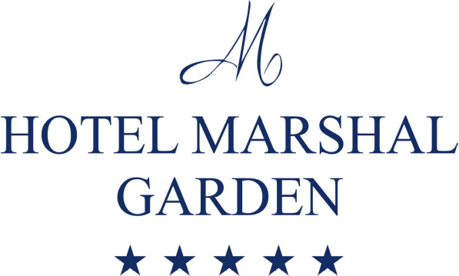
CLIENT : A.S.E.
OFERTA CAZARE
PERIOADA: 15.10-18.10.2014
CAZARE IN CAMERE SINGLE SUPERIOR
Tarif: 99 euro/ sgl. ( mic dejun,cocktail si taxe incluse) ;

Facilitati:
- Acces gratuit la fitness si sauna;
- Internet wirelless gratuit;
- Acces gratuit in parcarea subterana;
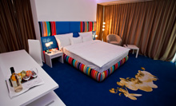
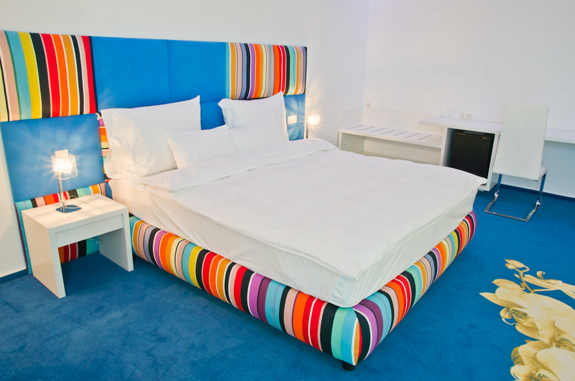
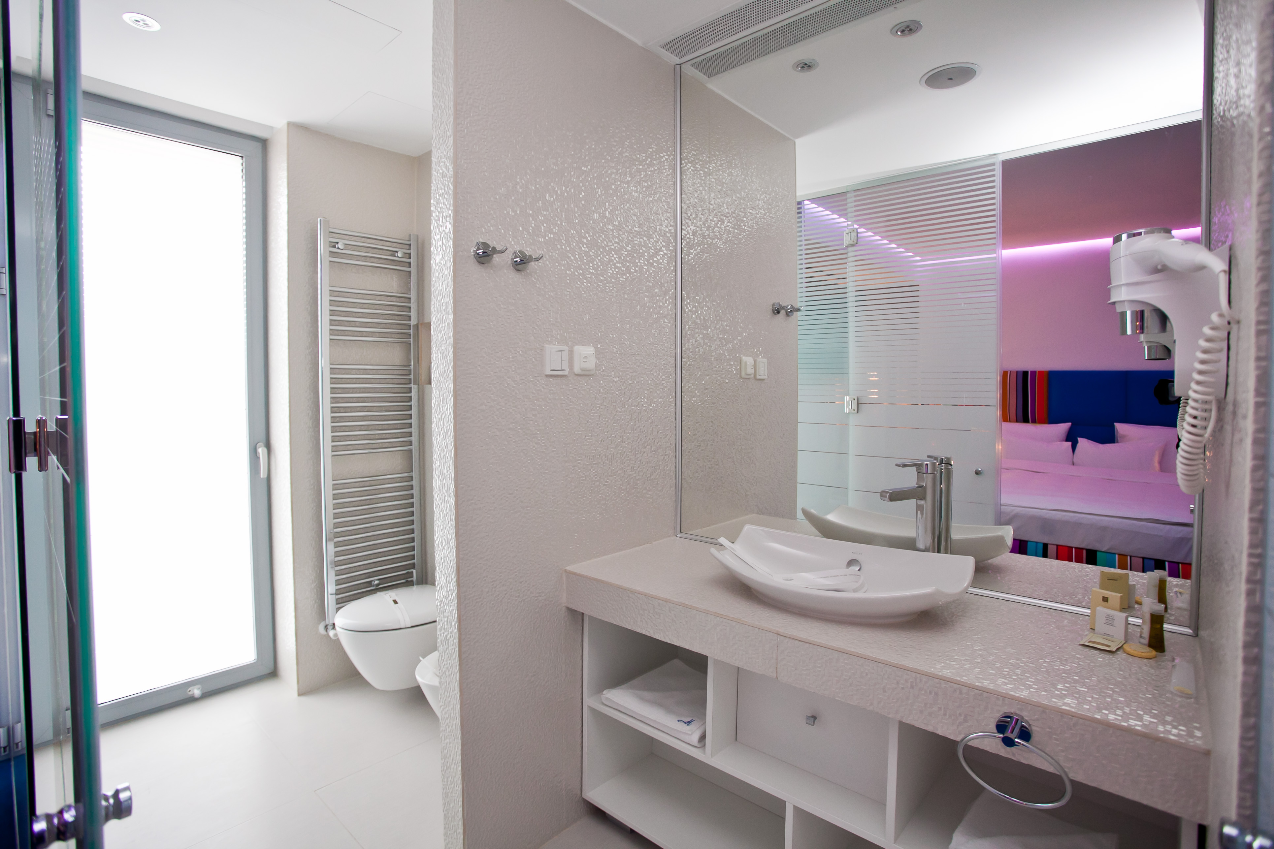
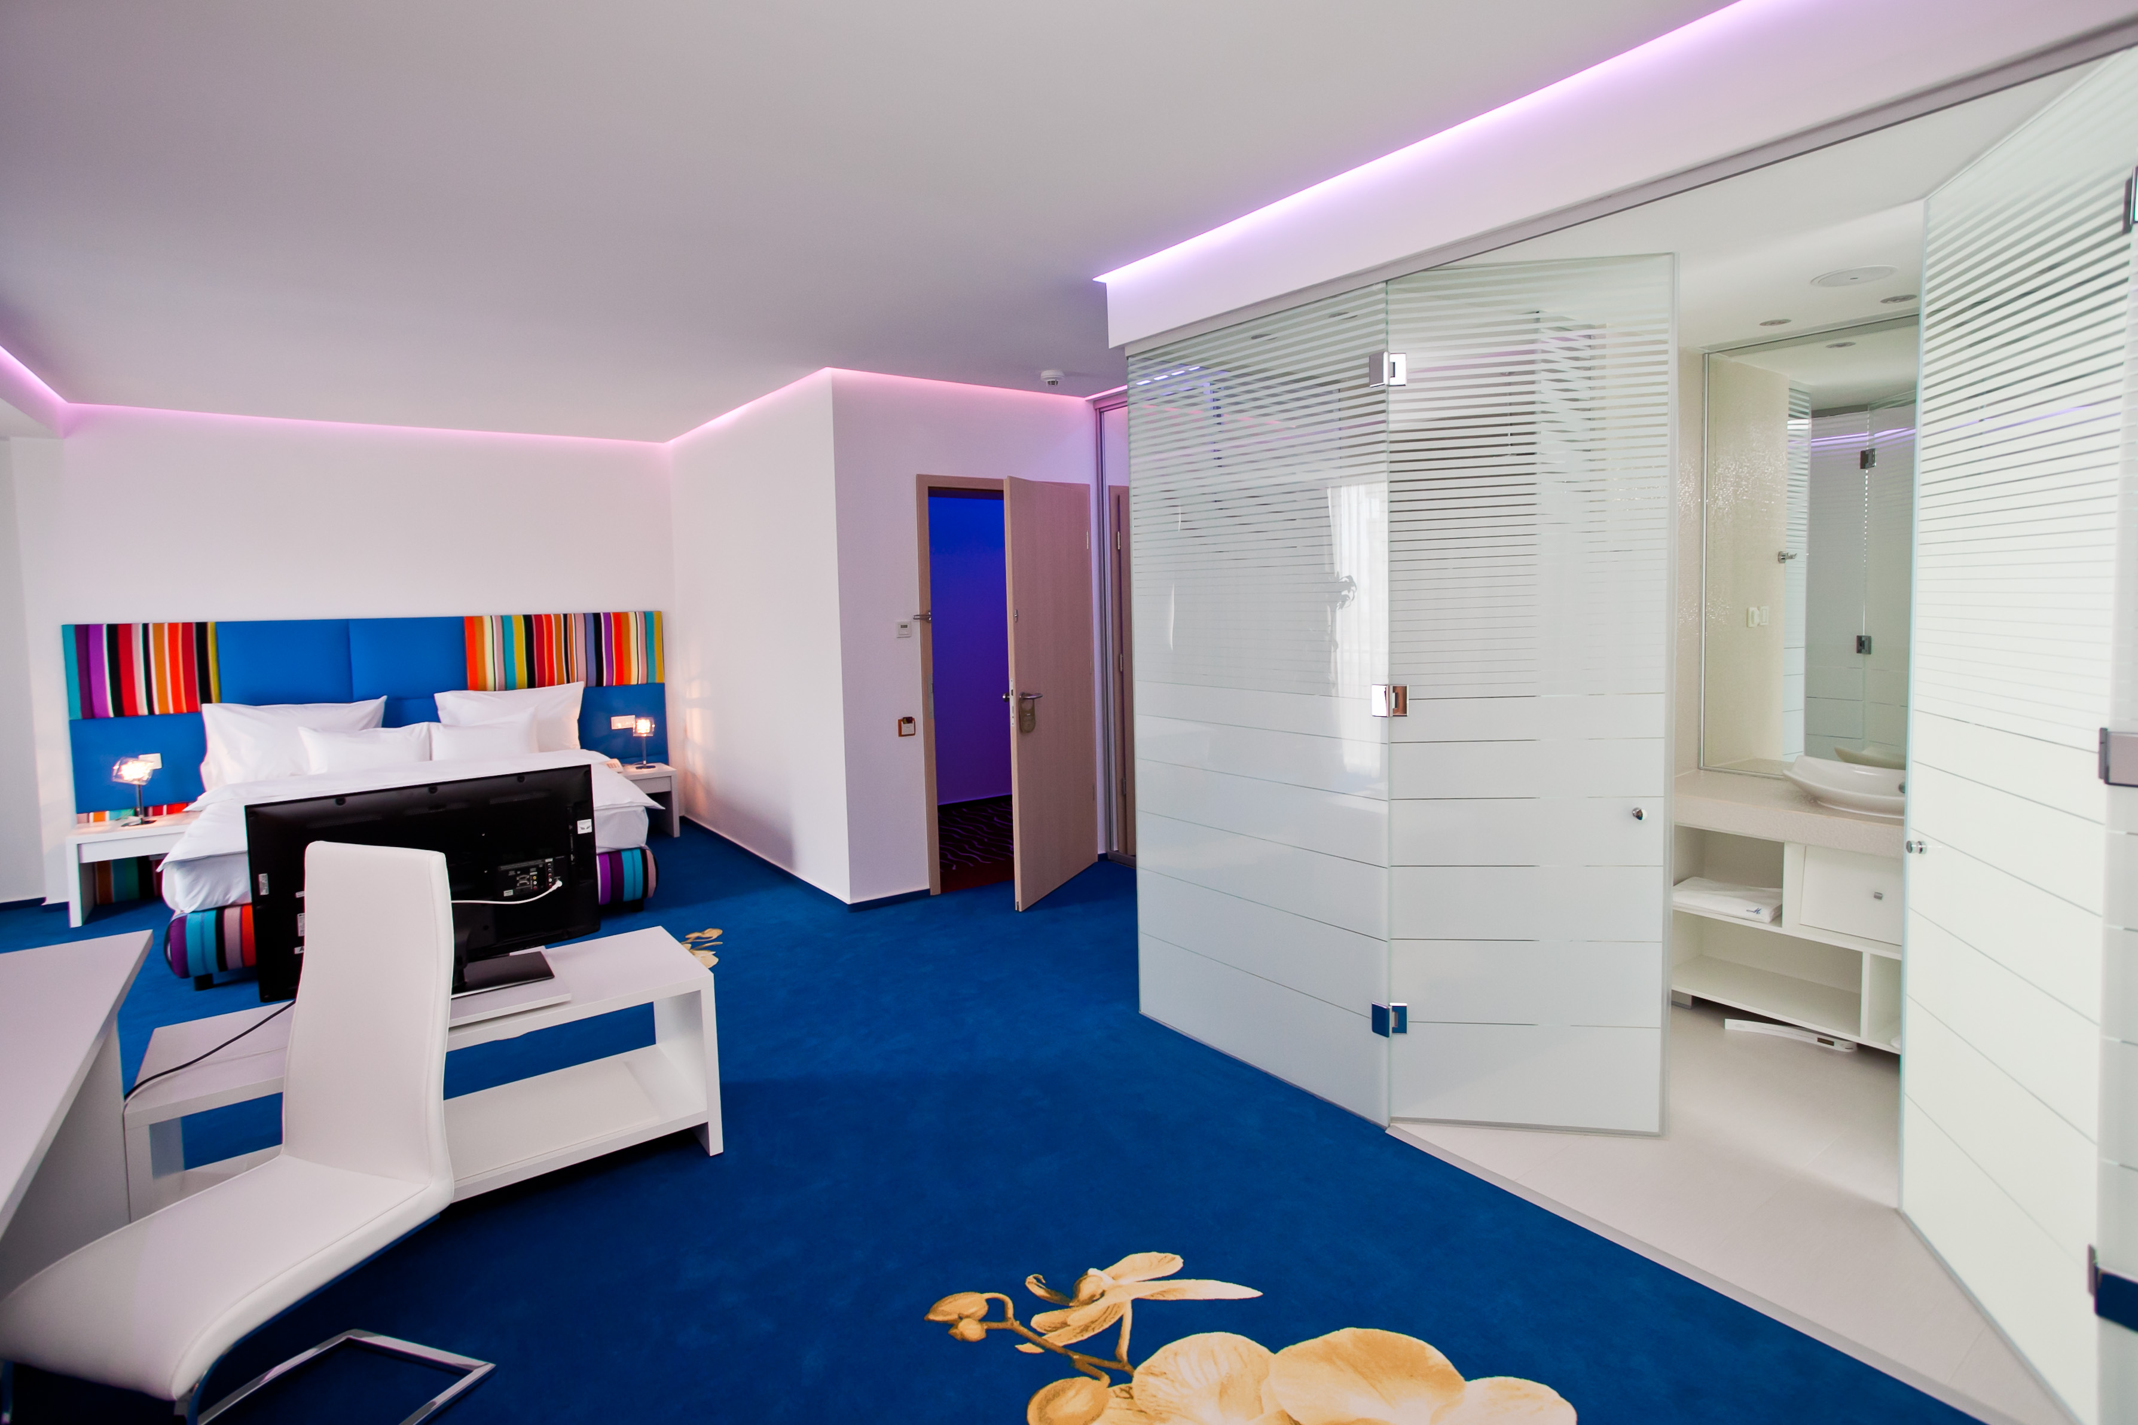
Web: | www.hotelmarshalgarden.ro

